DMCAAS-8614

8664-1 As an IQC user, I see new Site of Service Setting on Review Summary screen

**Preparation**

**SOS Benchmark data loader**

* Download the ZIP CSV file <https://jira.healthcareit.net/secure/attachment/2931733/SOS%20Load%20File%20v4.csv>
* Load SOS CSV File to End point /siteofservices

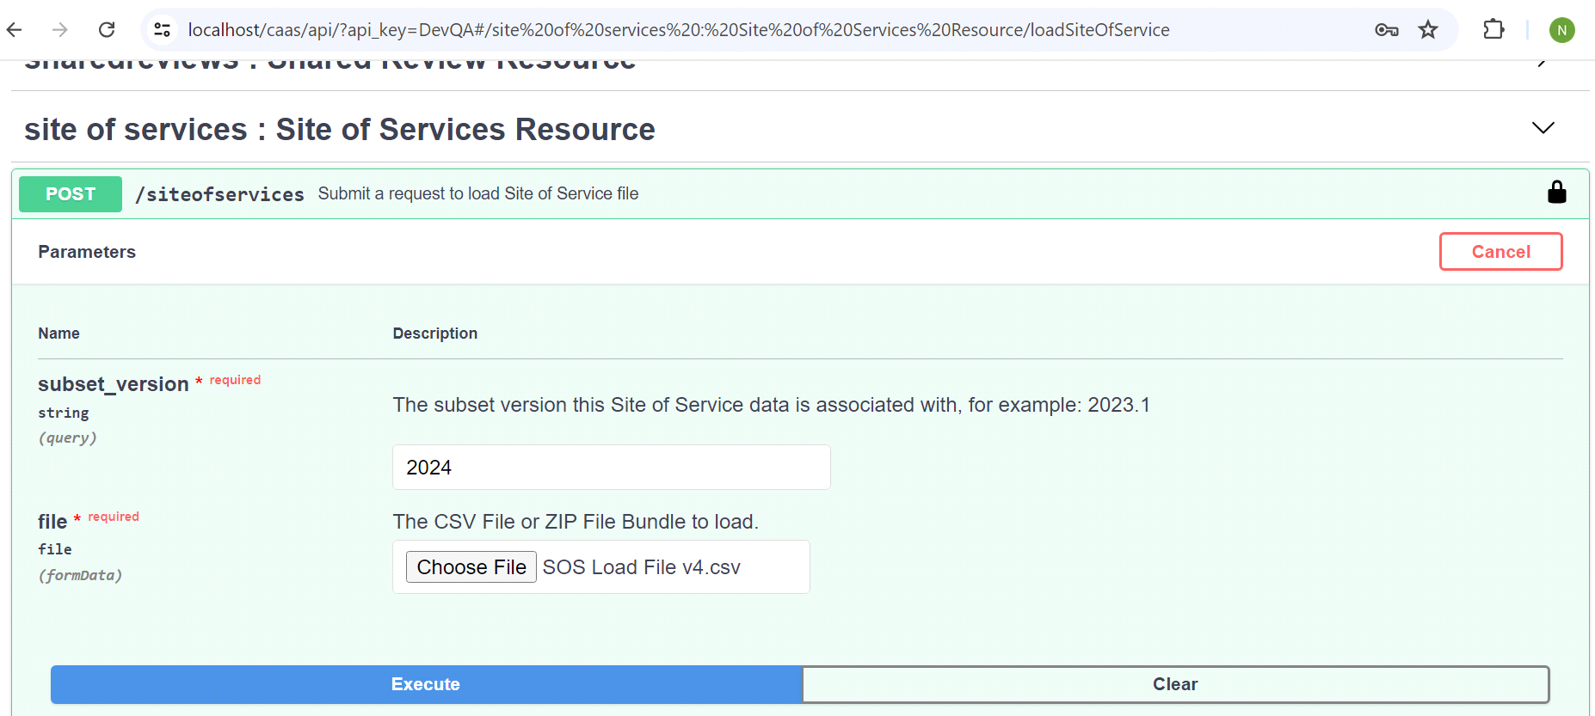

**Enable SOS Medicare Procedure and Care Procedure**

* Execute SQL statement to enable products, Medicare Procedures ('MDCR-PROCEDURES') and CP: Procedures('PROCEDURES'), BH: Procedure Q&A(BHPROCEDURES)
* -- Insert SoSSource regarding 'BHPROCEDURES','PROCEDURES' and 'MDCR-PROCEDURES'

INSERT INTO SUBSET_PROPERTY (SUBSET_PROPERTY_ID, SUBSET_ID, NAME, DESCRIPTION, VALUE, DATA_TYPE)

* SELECT SUBSET_PROPERTY_SEQ.nextval, smv.LATEST_REVISION_SUBSET_ID, 'SoSSource', 'SoS Source', 'ALL', 'string'
* FROM SUBSET_MINOR_VERSION smv
* JOIN CATEGORY_SUBSET_IDENT_ASSOC csia ON smv.SUBSET_IDENTIFIER_ID = csia.SUBSET_IDENTIFIER_ID
* JOIN CATEGORY c ON csia.CATEGORY_ID = c.CATEGORY_ID
* JOIN PRODUCT_VERSION pv ON c.PRODUCT_VERSION_ID = pv.PRODUCT_VERSION_ID
* JOIN PRODUCT p ON pv.PRODUCT_ID = p.PRODUCT_ID
* WHERE smv.ACTIVE = 1
* -- AND p.PRODUCT_CID = 'MDCR-PROCEDURES'
* -- AND p.PRODUCT_CID = 'BHPROCEDURES'
* AND p.PRODUCT_CID = 'PROCEDURES'
* AND pv.VERSION_CID = 'RM24';
* -- Insert SoSAge regarding 'BHPROCEDURES','PROCEDURES' and 'MDCR-PROCEDURES'
* INSERT INTO SUBSET_PROPERTY (SUBSET_PROPERTY_ID, SUBSET_ID, NAME, DESCRIPTION, VALUE, DATA_TYPE)
* SELECT SUBSET_PROPERTY_SEQ.nextval, smv.LATEST_REVISION_SUBSET_ID, 'SoSAge', 'SoS Age', 'ADULT', 'string'
* FROM SUBSET_MINOR_VERSION smv
* JOIN CATEGORY_SUBSET_IDENT_ASSOC csia ON smv.SUBSET_IDENTIFIER_ID = csia.SUBSET_IDENTIFIER_ID
* JOIN CATEGORY c ON csia.CATEGORY_ID = c.CATEGORY_ID
* JOIN PRODUCT_VERSION pv ON c.PRODUCT_VERSION_ID = pv.PRODUCT_VERSION_ID
* JOIN PRODUCT p ON pv.PRODUCT_ID = p.PRODUCT_ID
* WHERE smv.ACTIVE = 1
* -- AND p.PRODUCT_CID = 'MDCR-PROCEDURES'
* -- AND p.PRODUCT_CID = 'BHPROCEDURES'
* AND p.PRODUCT_CID = 'PROCEDURES'
* AND pv.VERSION_CID = 'RM24';
* -- Update SoSLookup regarding 'BHPROCEDURES','PROCEDURES' and 'MDCR-PROCEDURES'
* update subset_property
* set value='true'
* where name = 'SoSLookup'
* and subset_id in
* (select smv.LATEST_REVISION_SUBSET_ID FROM SUBSET_MINOR_VERSION smv
* JOIN CATEGORY_SUBSET_IDENT_ASSOC csia ON smv.SUBSET_IDENTIFIER_ID = csia.SUBSET_IDENTIFIER_ID
* JOIN CATEGORY c ON csia.CATEGORY_ID = c.CATEGORY_ID
* JOIN PRODUCT_VERSION pv ON c.PRODUCT_VERSION_ID = pv.PRODUCT_VERSION_ID
* JOIN PRODUCT p ON pv.PRODUCT_ID = p.PRODUCT_ID
* WHERE smv.ACTIVE = 1
* -- AND p.PRODUCT_CID = 'MDCR-PROCEDURES'  
  -- AND p.PRODUCT_CID = 'BHPROCEDURES'
* AND p.PRODUCT_CID = 'PROCEDURES'  
  AND pv.VERSION_CID = 'RM24');
* Using the SQL below to check Whether the setting is well-configured
* Select *
* from SUBSET_PROPERTY where name in ('SoSSource','SoSAge','SoSLookup')
* and subset_id in
* (select smv.LATEST_REVISION_SUBSET_ID FROM SUBSET_MINOR_VERSION smv
* JOIN CATEGORY_SUBSET_IDENT_ASSOC csia ON smv.SUBSET_IDENTIFIER_ID = csia.SUBSET_IDENTIFIER_ID
* JOIN CATEGORY c ON csia.CATEGORY_ID = c.CATEGORY_ID
* JOIN PRODUCT_VERSION pv ON c.PRODUCT_VERSION_ID = pv.PRODUCT_VERSION_ID
* JOIN PRODUCT p ON pv.PRODUCT_ID = p.PRODUCT_ID
* WHERE smv.ACTIVE = 1
* -- AND p.PRODUCT_CID = 'PROCEDURES'
* -- AND p.PRODUCT_CID = 'BHPROCEDURES'
* AND p.PRODUCT_CID = 'MDCR-PROCEDURES'
* AND pv.VERSION_CID = 'RM24')
* order by SUBSET_PROPERTY_ID desc;

**AC1: Document display of Site of Service data for IQ Benchmark SoS on the Review Summary PDF: CP: Procedures or BH: Services products only**

1. **Review Level** shows SoS setting (**No Setting Determined**) and LTD flag from Sos Setting,  
   **Recommendation Service level** shows Benchmark Setting including **LTD flag** and Source (IQ) with **Age Range**.

* Product: BH: Procedures Q&A
* Version: 2024
* Subset: Stereotactic Introduction, Subcortcal or Cortical Eletrodes
* SosSource: IQ
* SoSAge: Adult
* SoSLookup: true
* Result:
* 1. Begin Medical Review
* 2. Select Age Adult >18
* 2.  
  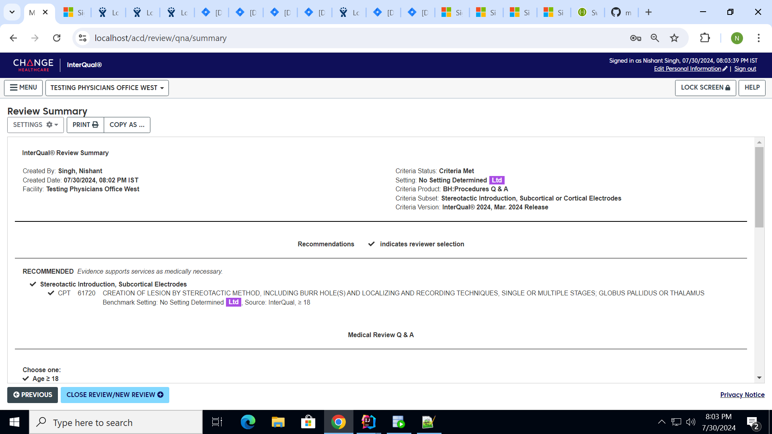

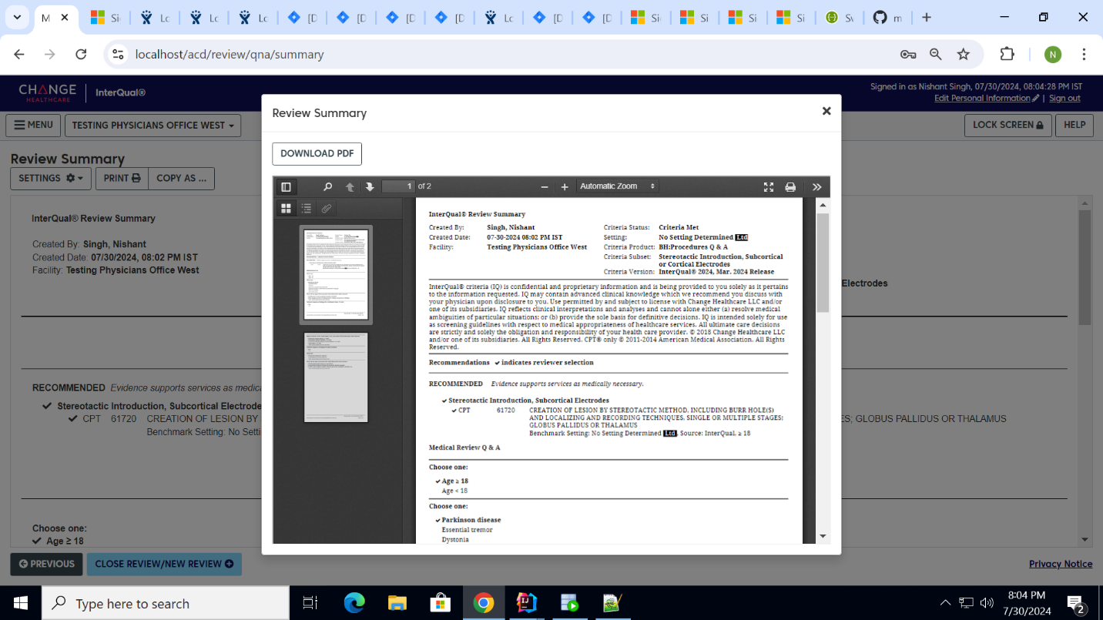  
  
  
  
  
2. Review Level shows SoS setting (No Setting Determined) and LTD flag from Sos Setting,  
Recommendation Service level shows Benchmark Setting **No LTD flag and No CPT code selected.**

* Product: BH: Procedures Q&A
* Version: 2024
* Subset: Paliperidone palmitate (Invega Hafyera)
* SosSource: IQ
* SoSAge: Adult
* SoSLookup: true
* Result:  
  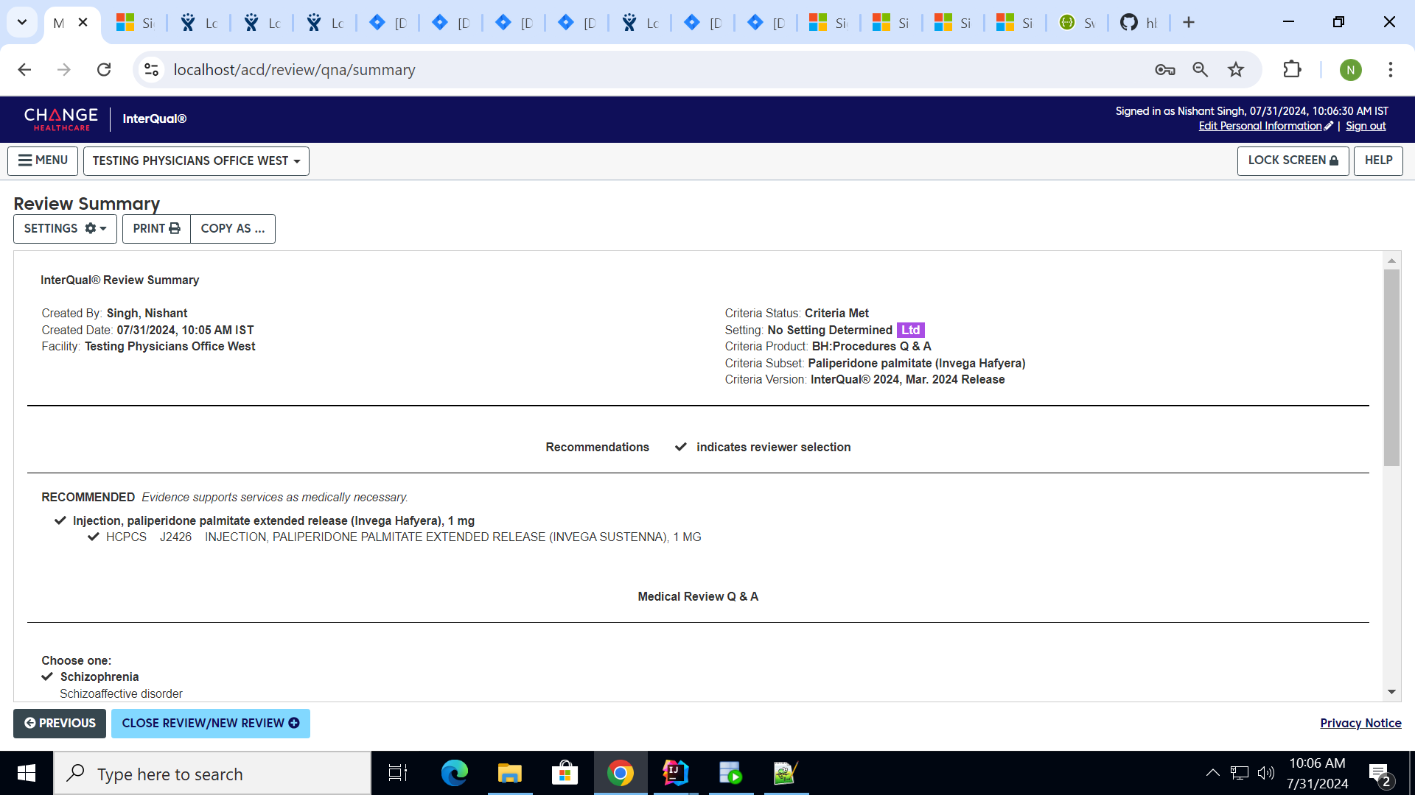

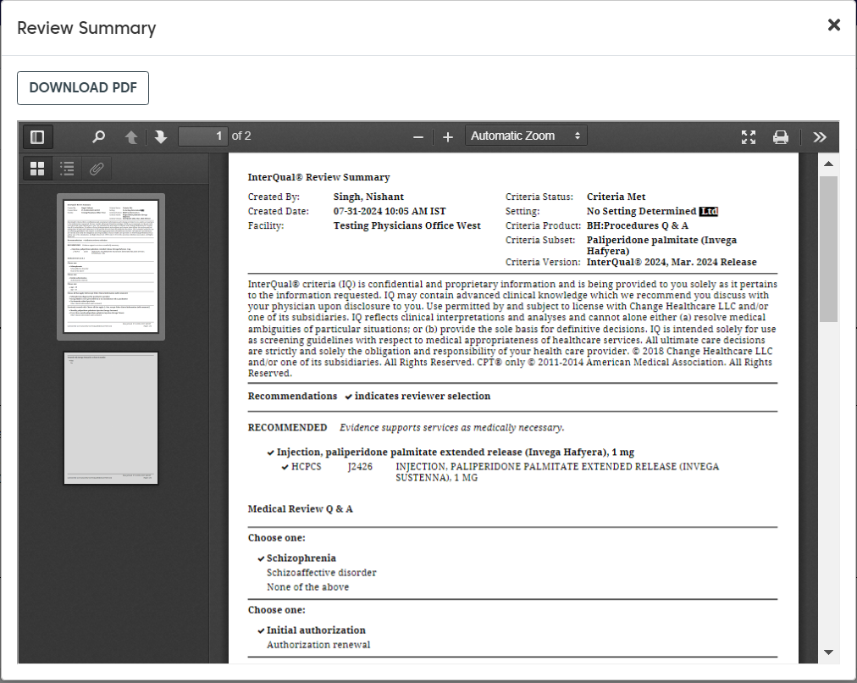  
3. Review Level shows SoS setting (No Setting Determined) and LTD flag from Sos Setting,  
Recommendation Service level shows Benchmark Setting **No LTD flag and CPT code selected.**

* Product: CP: Procedures
* Version: 2024
* Subset: TMS
* SosSource: IQ
* SoSAge: Adult
* SoSLookup: true
* Result:  
  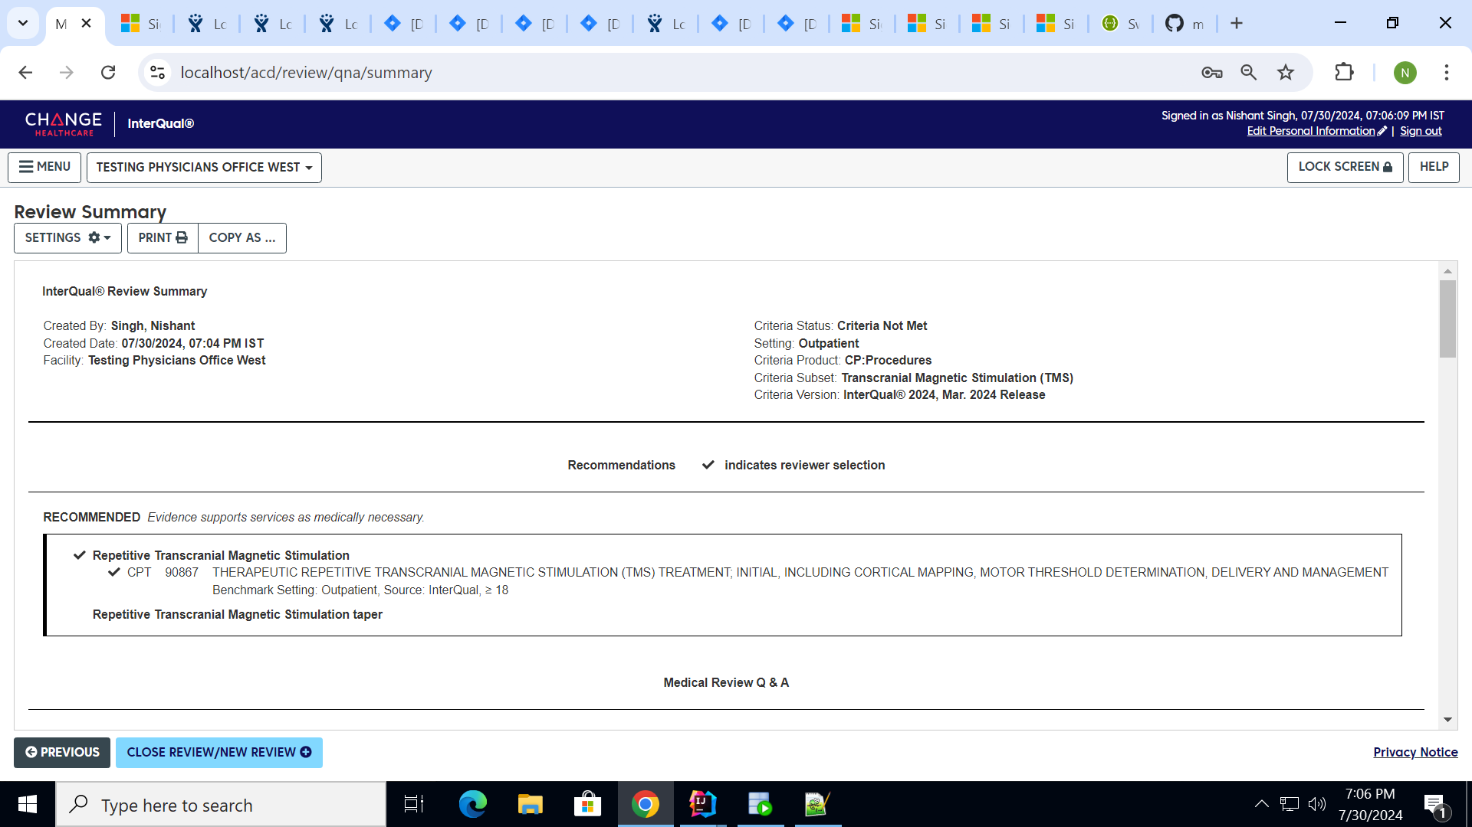

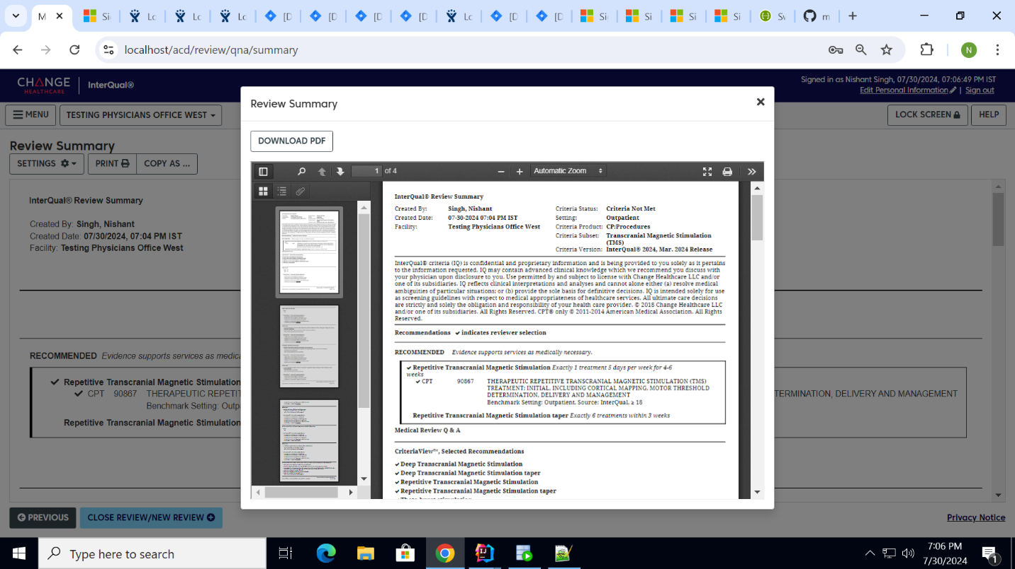

**AC2: Document display of Site of Service data for CMS Benchmark SoS on the Review Summary PDF: Medicare: Procedures**

* Product: Medicare: Procedures
* Version: 2024
* Subset: TMS (CGS)
* SosSource: CMS
* SoSAge: Adult
* SoSLookup: true
* Expected Result:   
  Review Level shows SoS setting (No CMS Setting Available).  
  Recommendation Service level shows Benchmark Setting and Source (CMS) with No Age Range.   
  